Week Commencing Monday March 30th 2020 – Friday 3rd April 2020
Scheme of Work for 3rd class for 1 week
Dia Daoibh!
I hope you and all your family are well and keeping safe at this time. I understand that it challenge to continue to have a routine at home and you’re great to be trying to keep doing your school work. Don’t worry if you didn’t get everything done over the past two weeks. I recommend for this week that you try to complete some of the work assigned this week. I have posted assignments in Gaeilge, Maths and English. The work can be completed at home and is similar to the work we would have covered in school. The work posted on Google classroom is like menu and can pick extra work to do if you wish. If you have any questions or want to send me something you did with your family (baking, going for a walk), I would only be delighted to hear from you! Hopefully, we will be back in school again soon.
Stay safe and be kind to everyone at home.
Best wishes,
Ms. Walsh
Gaeilge:
- Comhrá - Bí ag labhairt as Gaeilge ar feadh 5-10 nóiméad gach lá. Bain úsáid as an leathanach atá ar Google Classroom.
Scríbhneoireacht
Nuacht
- Gach maidin scríobh 5 abairti mar gheall ar nuacht an lae. Inniu an …, Inné an …, Amárach an …, An aimsir, mé féin, ar scoil. (Send me a picture/type your work and send it to me of one day’s news)

Léitheoireacht
- Am Don Léamh: Lch 24 & 25 (complete in Irish copy)

English
Reading
- Reading Zone – Read ‘How Fionn Became Leader of the Fianna’ p. 64-65
- Complete activities p.66-67 (A, B and C)
- Additional reading will be assigned during the week including reading comprehensions and a reading book online.
Using your reading novel, Write a character description of your favourite character. You can email your description to michelle@holytrinitynsfethard.com
Writing
- Write a diary entry of after the week. Try to include some activities you did with your family. It will be interesting to read in the future!
- Write a letter to persuade your teacher to give no homework for the rest of the year.
Useful websites
- IXL website https://ie.ixl.com/?partner=google&campaign=127173208&adGroup=5602337128&gclid=CjwKCAjwguzzBRBiEiwAgU0FT-XEjHdKCb-Npb_KBqu5AXrKP9JcixpcpPaEby0NdORc_VdwQ7-IkBoCDxcQAvD_BwE Choose class and then click into English skills and practice sentence structure, verbs etc.
- I know a lot of you like David Walliams and he is doing a read aloud every day from one of his books. Take a look at his website https://www.worldofdavidwalliams.com/ for more information. I hope you enjoy listening to his stories.
Maths
- Master Your Maths – Week 26 (Mon- Thurs) and Friday Test.
- Tables – x12
- Busy at Maths p. 97 Q1-5, p.99 Q.1, p. 100 Q.1 and p. 101 Q. 2 and 3
- Busy at Maths p. 123 Q1-3, p.124 Q.3, p. 125 Q.4 and p.126 Q1 and Q.4
- Solve emoji- https://www.solvemoji.com/
- Maths Tables Games - https://www.mathsonline.com.au/games/times_tables
- IXL website https://ie.ixl.com/?partner=google&campaign=127173208&adGroup=5602337128&gclid=CjwKCAjwguzzBRBiEiwAgU0FT-XEjHdKCb-Npb_KBqu5AXrKP9JcixpcpPaEby0NdORc_VdwQ7-IkBoCDxcQAvD_BwE Choose class and then click into Maths skills and practice time, fractions, multiplication
Music- Practise your instrument every week. Listen to a song that makes you feel happy!
Religion
- Information PowerPoints on Easter-Holy week-Holy Thursday –Easter Sunday. Please find them attached. Talk through these.
- Complete activity on the Stations of the Cross (available on Google classroom)
PE
- Being active every day is important! This could be playing football, soccer, hurling, running, skipping, cycling, walking the dog or any other form of activity you can do with your family.
- Joe Wicks The Body Coach is doing live PE on YouTube for 30 minutes everyday from 9am. I have included last weeks videos in the PE folder on Google Classroom.
- Spell your name PE! – Please find in PE on Google Classroom – get some of your siblings involved in this one!
SPHE- Have a chat over the phone with grandparent/ friend that you haven’t seen in a while.
- Design and decorate a card for a family member to show them that you are grateful for everything they do for you.
SESE:
- Finish Geography Project – Don’t worry if its not on A3/A2 paper. Any paper will be ok 😊 If you have it finished, send me a picture to my email, I’d love to see it!
- Science – Recipe for Muffins. Write the experiment into your homework hardback. Please email me a picture of the delicious muffins that you make at home. * There is no need to make a video after you have completed the experiment. 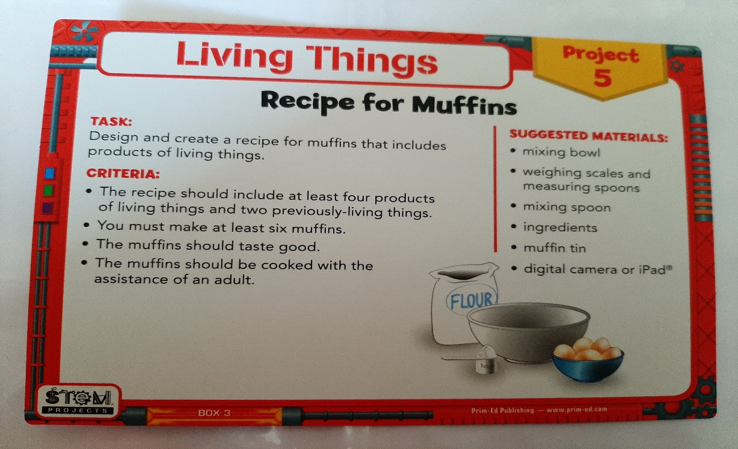
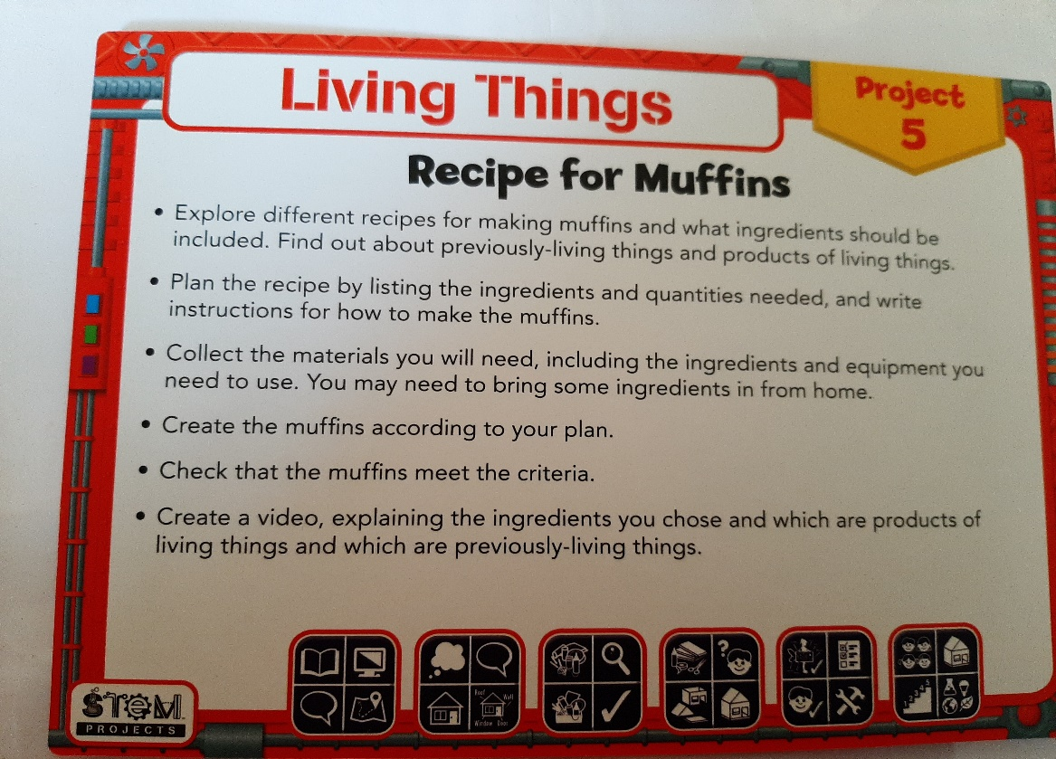

Art
- Make an Easter Egg Wreath – Guidelines in Art on Google classroom.

There is no pressure to complete all of this work. It is simply a guide to what would have been covered if we were in school. Extra activities are also available on Google classroom for most subjects. You can email me anytime at michelle@holytrinitynsfethard.com if you need any guidance or want work corrected.

Stay safe,
Ms Walsh

