Week Commencing Monday March 30th 2020
Scheme of Work for 5th class for 1 week
I recommend that you spend 1 quality hour every day on school work. If you have any questions please email me. I would love to see some work you have completed. Why not take a picture and email to me. I’d love to hear from you. Hopefully we’ll all be back to normal soon.
Gaeilge:
Scribhneoireacht: Aiste
Gach maidin scríobh 5 abairti mar gheall ar cad a rinne tú inné
Useful website for Irish is Séideán Sí www.seideansi.ie
Leigh Leat www.leighleat.com

English: Novel: Any novel you have recently read or are reading yourself
- Type your book report and email to seamusbreen@holytrinitynsfethard.com
- Write a character description of your favourite character

Postcard- Use An Posts Post Cards to write to an elderly neighbour. These are free to post.
Any writing lessons I would love so see you’re finished product - why not take a picture and email it to me!

Maths: FIO Unit 16 Page 50
Master Your Maths: Next 5 pages to be completed
Useful Websites:
Topmarks - useful games for maths facts include The Daily 10 and Hit the Button- This is an excellent website
IXL- ie.ixl.com
Speed Math app- Pupils race against the clock to answer 15 math facts.
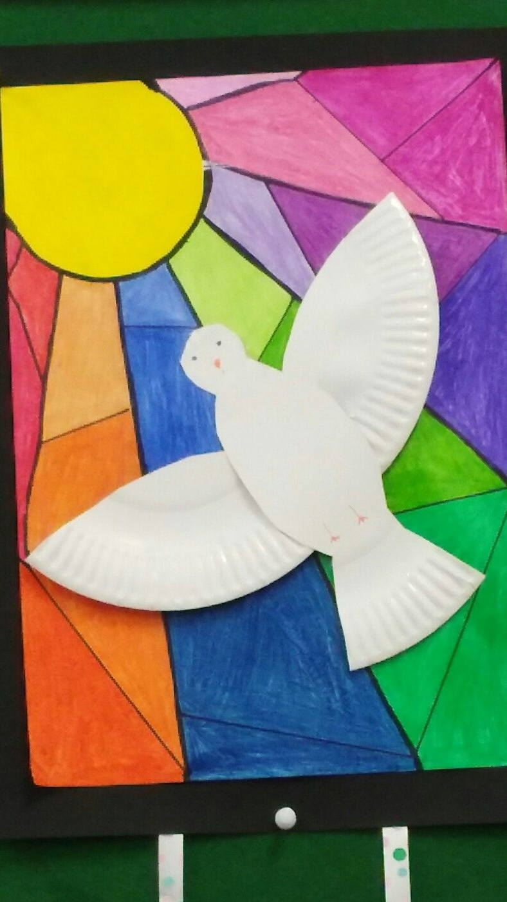
Religion: Stained Class Window - Colour with bright colours
Draw on A4 white paper
Go back over the Fruits and Gifts of the Holy Spirit
Write a prayer to the Holy Spirit asking to keep you and your family safe at this time

Music- Listen to some of your favourite music every day
PE- Get out on your bike when the weather is good- wear your helmet and hi-viz jacket
Practice your hurling and football skills
Go for a walk with your family
SPHE- Dress your bed and tidy your room every morning
Agree a list of jobs with your parents at the beginning of each day- hoovering, filling/emptying the dishwasher, bringing in fuel, taking out ashes, cleaning windows, tidying presses etc.
SESE: Gas Powered Boat- Write and draw an experiment report and put in your SESE scrapbook
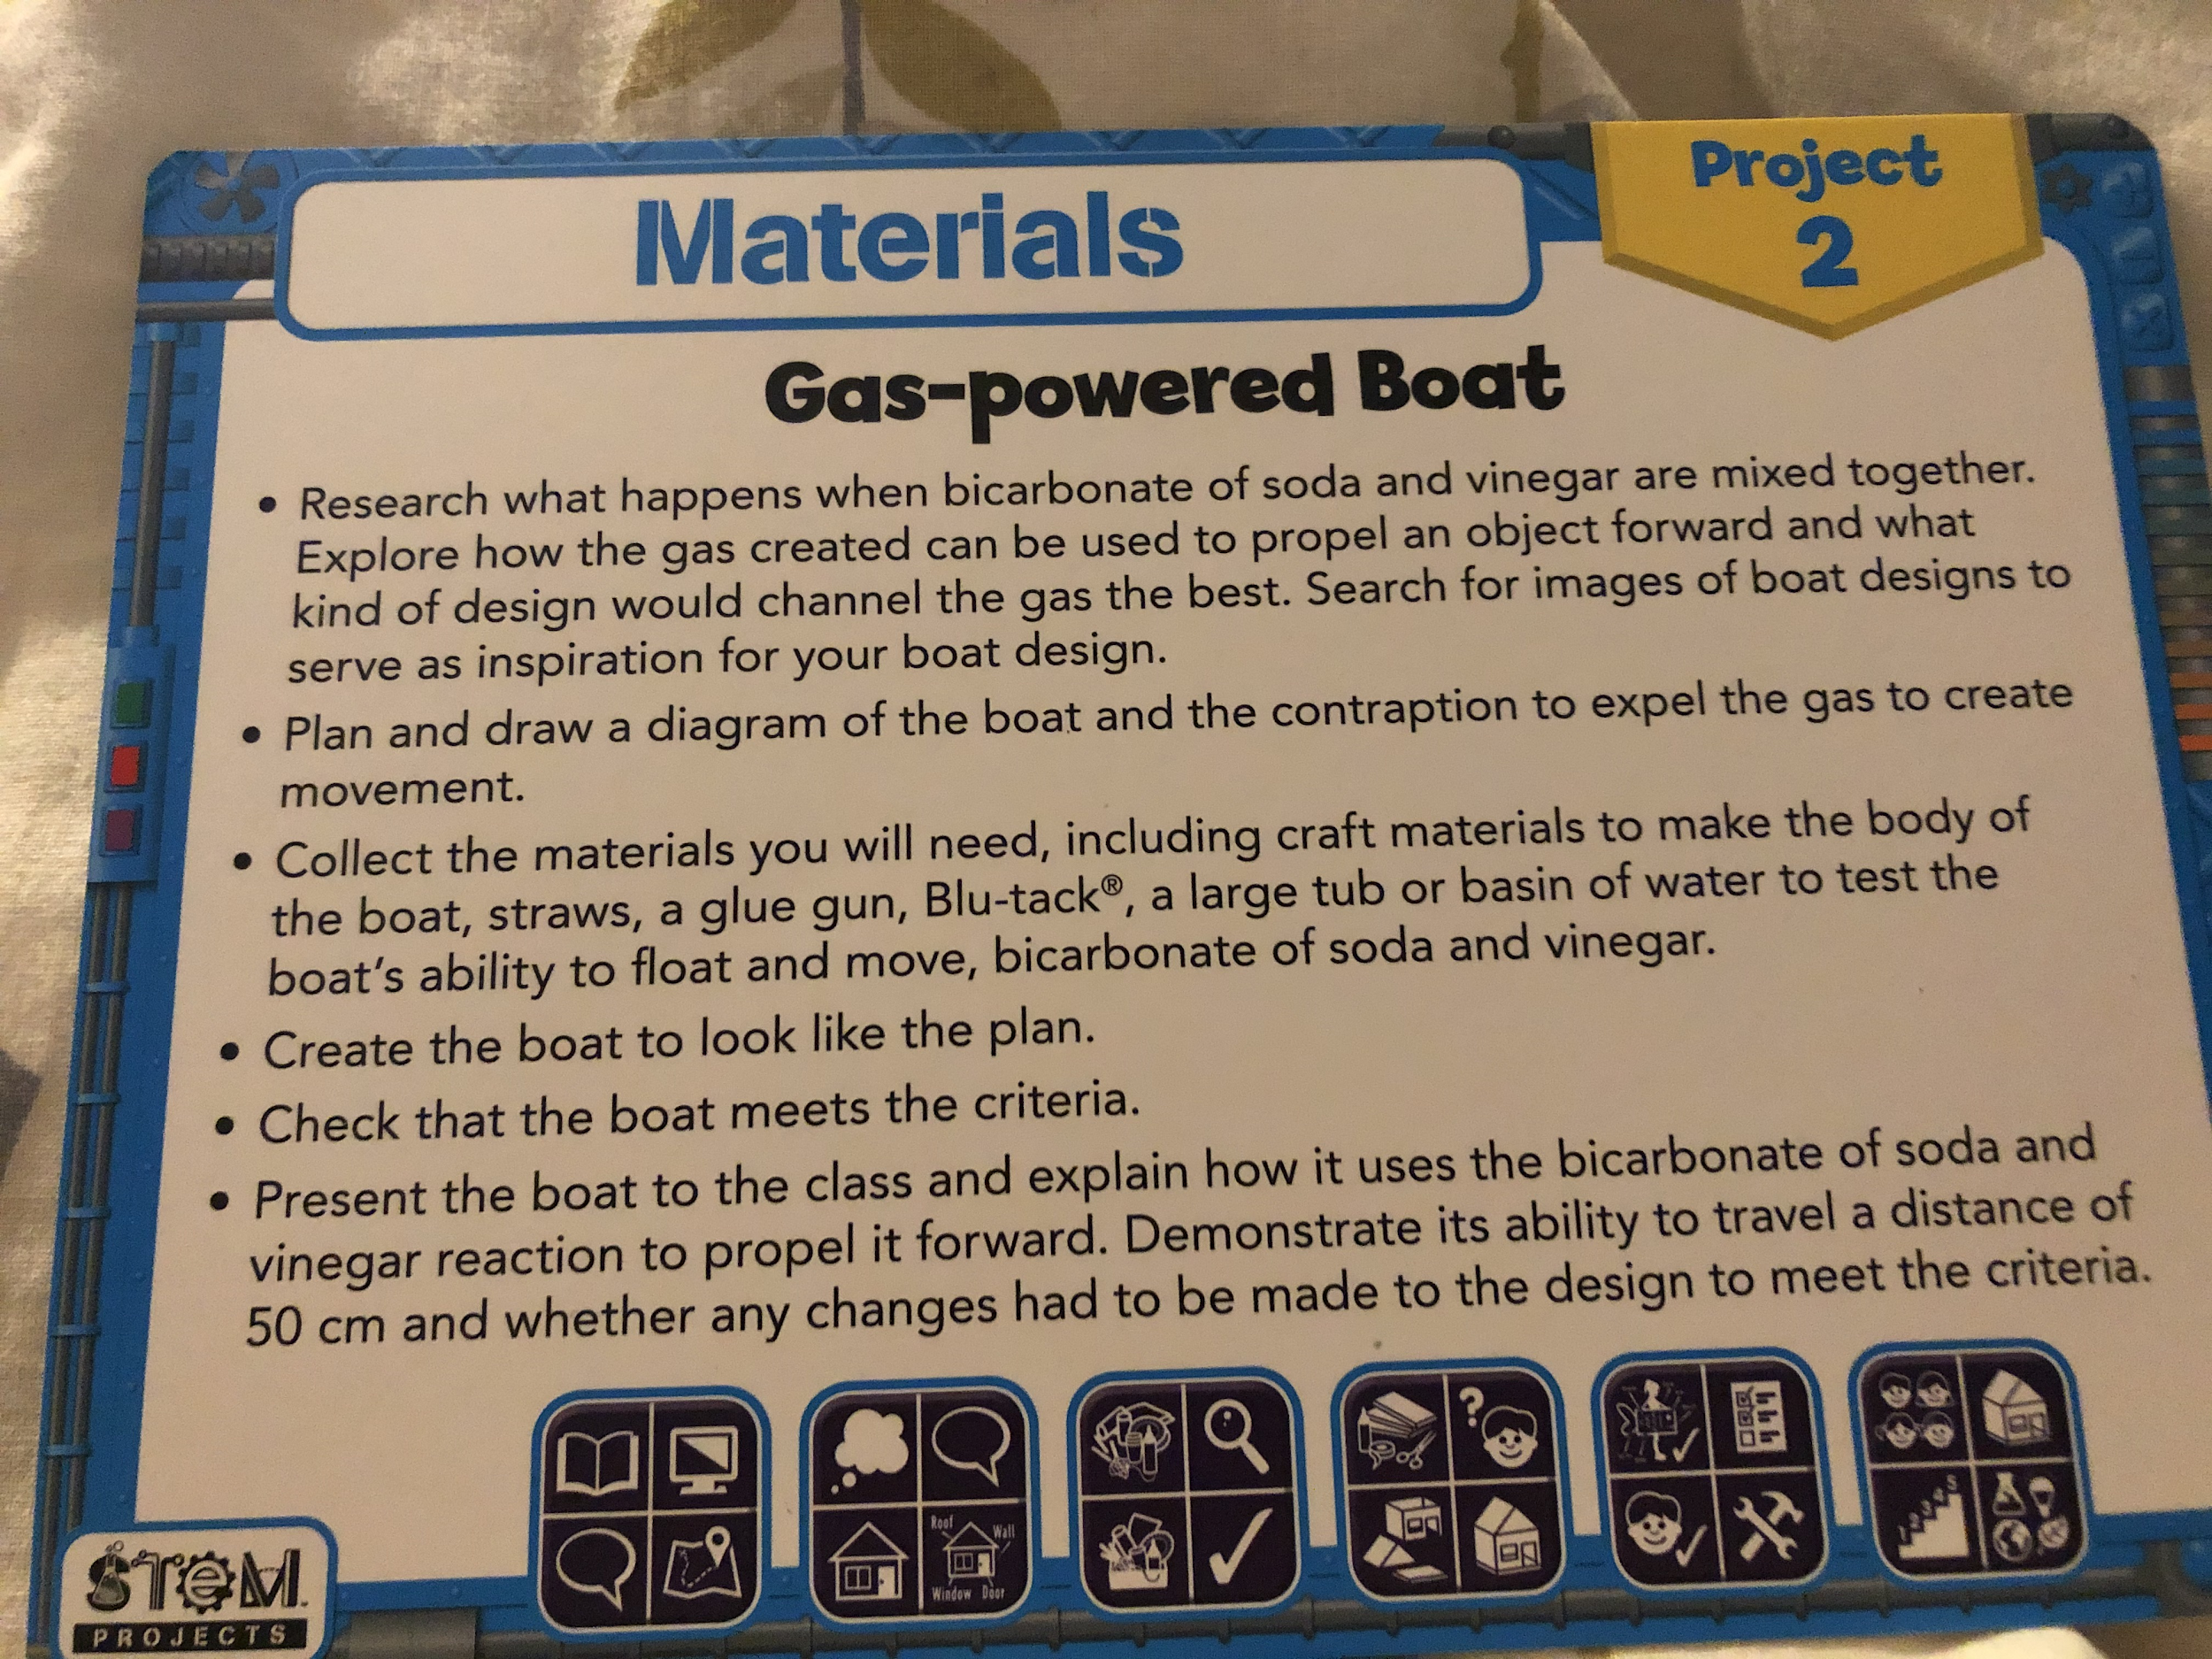
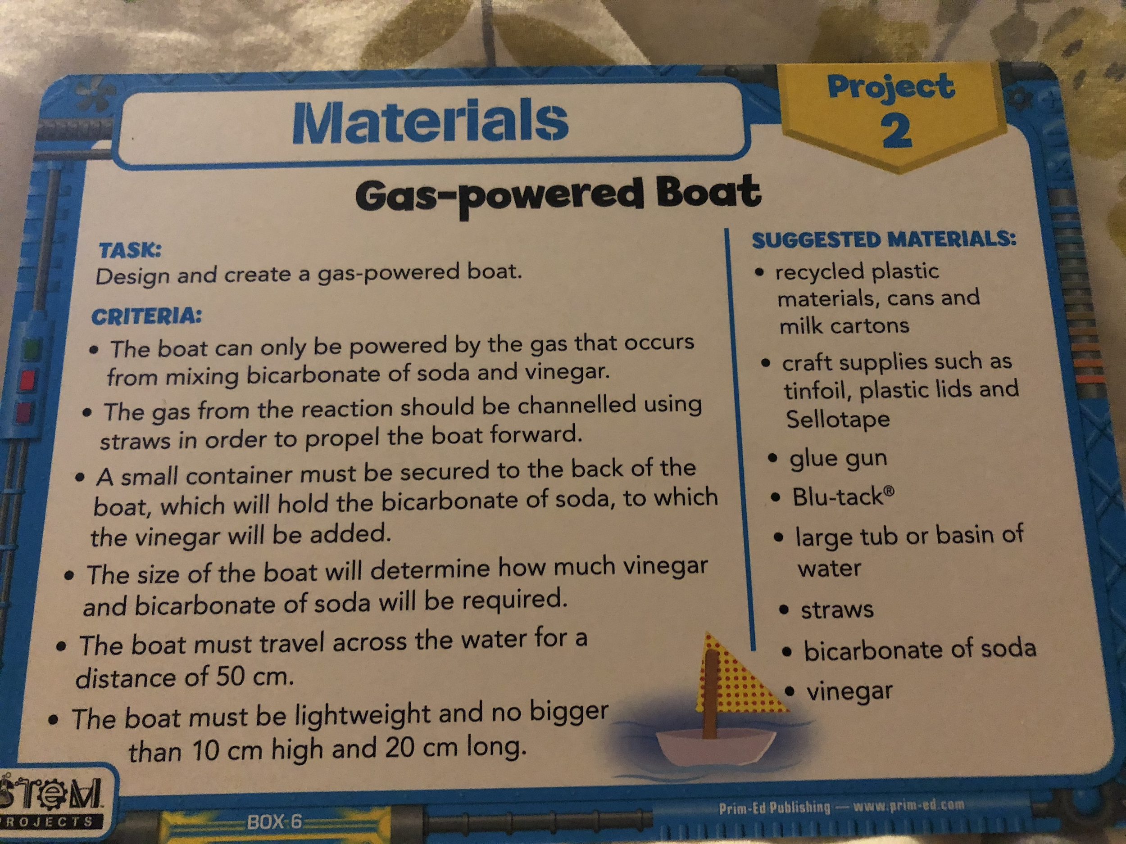

This is work you could complete when you are at home. There is no pressure to complete any/all of this work. It is simply a guide to what would have been covered if we were in school. You can email me at seamusbreen@holytrinitynsfethard.com if you need any guidance or what work corrected.
Mr Breen
Class Teacher

